**GrandTotal**

*by “Echipa2 - The Wanderers”™/ © Integrated Software Solutions*

**State-of-the-art and risk assessment**

**General description**

**The application will enable the centralization of data related to product sales made through GrandChef (which contains all functions: marking, loyalty, inventory management) application in order to obtain statistical information.**

**Application users will be manufacturing - importing companies interested in retail sales of its products.**

**Distributed System used by GrandChef software:**

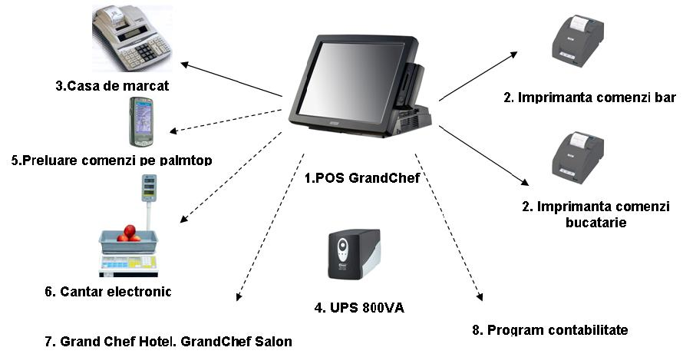

**What did the others** - Inventory Management Software Systems

# [**inFlow**](http://www.inflowinventory.com/)

**inFlow is an inventory management software focused on small and medium businesses. The company has been growing since 2007 and now claims over 750,000 users.**

## [**Carta**](http://getcarta.com/)

**Carta is the online offering from the people who brought you inFlow. Carta also offers a slimmed down free version.**

## [**Odoo**](https://www.odoo.com/)

**Odoo is designed as an ERP, but thanks to the software’s add-on app layout, you can make it as large or small as your business requires. For inventory management, you’ll probably want to take advantage of at least the warehouse management system and perhaps the purchase or point of sales system as well.**

## [**ABC Inventory**](http://almyta.com/abc_inventory_software.asp)

**It’s a free package for a single user, allowing you to manage multiple warehouses, serial numbers, warranties, and a host of other inventory related data. This free version is really designed to be run on one computer, though, as multiple workstations can’t sync the same data.**

**Techniques and Methodologies used**

**The Java Transaction API**

Java Transaction API (JTA) specifies standard Java interfaces between a transaction manager and the parties involved in a distributed transaction system: the resource manager, the application server, and the transactional applications.

**Spring**

Spring is the most popular application development framework for enterprise Java. Millions of developers around the world use Spring Framework to create high performing, easily testable, reusable code.

The Spring web MVC framework provides model-view-controller architecture and ready components that can be used to develop flexible and loosely coupled web applications. The MVC pattern results in separating the different aspects of the application (input logic, business logic, and UI logic), while providing a loose coupling between these elements.

* Security

Spring security is the highly customizable authentication and access-control framework. This is the security module for securing spring applications. But, this can also be used for non-spring based application with few extra configurations to enable the security features.

* Data

Spring Data REST builds on top of Spring Data repositories, analyzes your application’s domain model and exposes hypermedia-driven HTTP resources for aggregates contained in the model.

* Hibernate

The Spring Framework supports integration with Hibernate, Java Persistence API (JPA) and Java Data Objects (JDO) for resource management, data access object (DAO) implementations, and transaction strategies. For example, for Hibernate there is first-class support with several convenient IoC features that address many typical Hibernate integration issues. You can configure all of the supported features for O/R (object relational) mapping tools through Dependency Injection. They can participate in Spring’s resource and transaction management, and they comply with Spring’s generic transaction and DAO exception hierarchies. The recommended integration style is to code DAOs against plain Hibernate, JPA, and JDO APIs.

**Relevant Links**

[**http://www.oracle.com/technetwork/java/javaee/jta/index.html**](http://www.oracle.com/technetwork/java/javaee/jta/index.html)

[**https://www.progress.com/tutorials/jdbc/understanding-jta**](https://www.progress.com/tutorials/jdbc/understanding-jta)

[**https://www.odoo.com/**](https://www.odoo.com/)

[**http://getcarta.com/**](http://getcarta.com/)

[**https://www.inflowinventory.com/**](http://getcarta.com/)

[**http://almyta.com/abc_inventory_software.asp**](http://almyta.com/abc_inventory_software.asp)

[**http://www.grandchef.ro/**](http://www.grandchef.ro/)

**Resources and Tools**

### 

* **Browse Javadocs:** [**javax.transaction**](http://docs.oracle.com/javaee/5/api/javax/transaction/package-summary.html) **and** [**javax.transaction.xa**](http://docs.oracle.com/javaee/5/api/javax/transaction/xa/package-summary.html)
* **See the Java EE 6 Tutorial section:** [**JTA Transactions**](https://docs.oracle.com/cd/E19798-01/821-1841/bnciz/index.html)